Summerhouse Houston
Performance Analysis for 2023

Summerhouse’s Vision: To create opportunities for adults with IDD to belong and positively impact the Greater Houston community.

Summerhouse’s Mission: Summerhouse supports adults with IDD, their families, and our community through employment, volunteerism, and partnerships to foster a culture of belonging, choice, and respect.

History of Performance Management System

Summerhouse has consistently operated as a data-driven organization, particularly in the provision of services and training for members and clients. The term "members" refers to those with membership in Summerhouse's community inclusion/day program, while "clients" pertains to individuals served in employment services through the Texas Workforce Commission or Medicaid waiver.
For numerous years, Summerhouse has adhered to a strategic plan for various business functions. In April 2020, we began developing a comprehensive performance measurement and management plan. Utilizing the pandemic downtime, we immersed ourselves in understanding various program evaluation systems and familiarized ourselves with CARF requirements for such systems.
We identified responsible individuals within the organization for tracking outcomes and initiated baseline data tracking in Spring/Summer 2020 to establish clear targets. The full implementation of the system occurred in January 2021, and we are now presenting our third complete performance analysis report. For additional details about our plan, please consult the Administrative Policy Book on Program Measurement and Management.

Community Integration/Day Program………………………………………………………………………………………….... page 2
Community Employment Program…………………………………………………………………………………………. page 14
Business Function……………………………………………………………………………… page 22
Community Integration/Day Program

By the end of 2023, our community integration/day program served 40 individuals. During this time, we welcomed 9 new members while also discharging 6. Additionally, we expanded our program team by 4 new staff.
- A new position of Assistant Program Director/COO, filled by Meg Maradiago, has been established to provide support and training for staff, manage waivers and billing, handle parent engagement, and address facility-based concerns. This addition aims to enhance overall operational efficiency and ensure comprehensive support across various aspects of our organization.
- We maintained a strong focus on assisting members in securing regular supported employment positions within the community. Notably, our second member departed from Summerhouse, having successfully secured a full-time job. This accomplishment underscores our commitment to empowering members in their pursuit of meaningful employment opportunities.
- The program introduced over 20 completely new activities to their schedule, exploring and incorporating fresh experiences that differ from the previous ten years' findings! These included: Angel Pines Safari, paintball, laser tag, The Toy Museum, Immersive Gamebox, Houston Raceway, The Cistern, Seismique, Alief Library Center, Houston Interactive Zoo, Houston Museum of African American Culture, Old Town Harrisburg, Bryan Museum, Home Run Dugout, pickle ball, Bogies Billiards West, George H.W. Bush Presidential Library and Museum, The Woodlands Trolley, and The Museum of Illusions.
- 6 additional volunteer sites were incorporated: Billion Graves, SIRE, Main Street Ministries, Buffalo Bayou Partnership, Houston Pets Alive! and Target Hunger.
- Our ongoing commitment to staff development included training in positive practices, Mandt, and effective communication. Notably, two of our staff were certified in Mandt training. We continued to provide monthly training on various topics of health and safety that pertained to both staff and members.
- The decision was made to downsize Shred for Independence, as a significant number of members expressed a preference for volunteering in the community or securing community-based jobs.
- We successfully hosted 2 parent meetings that garnered substantial attendance and received positive feedback from all participants.
- We sent our COO to CARF 101 training, demonstrating our commitment to staying informed and maintaining a high standard of quality in our operations.
- We facilitated 6 PATH (Planning Alternative Tomorrows with Hope) meetings for our members. These meetings are instrumental in collaborative planning and creating paths for a positive and hopeful future.
- We allowed all members the opportunity to explore their futures by providing future planning classes.
- We invested in the professional development of an associate by sending her to a Dare to Lead training course designed to cultivate effective and courageous leadership skills.
- Members took an active role in planning their birthday celebrations, choosing the activities to take part in on their special day.
- We organized 3 of our in-service training courses to be led by community experts, covering essential topics such as leadership, communication, and diversity.
- Characteristics of members as of 12-31-23

Live at home with parents: 40

Average age: 25

Discharges/Follow-up

E - Moved to a different country, her parents will randomly send check-ins and she is doing well (June)
M - Disenrolled due to behavioral issues. Have followed up periodically and heard from her; she is attending Celebration Company. (June)
R - Officially ended in January due to being in another program in another county. Moved to the possible bottom of our waitlist, and we check in with his mom periodically (Jan).
S - Ended due to a full-time job (Aug). We continue to provide supported employment follow-along.
F - Disenrolled due to cost and getting a job, emailed Angie in October (Aug).
K - Disenrolled due to behavioral issues. His father checked in last month; still looking at other programs. (Oct)

- Effectiveness

Minimize the average time needed to master goals: In tracking the time required to master goals, we observed notable changes. The baseline from 2022 indicated 10 months for vocational goals and 13 months for social goals. In contrast, goals were achieved in 8 months for vocational and 11 months for social in the designated period. The actuals for 2023 showed an average of 11 months for vocational goals and 9 months for social goals.
It's important to acknowledge that various factors influence goal success. Notably, the transition to SMART goals has been completed to ensure timeliness. The increase in new members, with the associated time required for goal development, particularly in social aspects, has contributed to the observed trends. Additionally, the addition of several new volunteer sites has extended the time needed to meet these new goals. These insights provide a comprehensive understanding of the dynamics influencing goal achievement timelines. Recommend keeping goal.

Increase number of members employed (total percentage of members employed): By year’s end 27.5% (11 out of 40 members) had secured community employment. Although this falls short of our goal of 40%, it’s important to note that this figure differs from the numbers in the employment services analysis. Some members have jobs that we do not actively support, hence they are included in this count and not in supported employment.

A large factor contributing to the lack of member employment is the number of new members joining the day program. Additionally, we have encountered some parents expressing reluctance to enroll in the Texas Workforce Commission, which is crucial for obtaining the one-on-one funding necessary for employment support. Two members chose to leave their jobs during the year, while one member successfully transitioned to a full-time job.

Despite these challenges, our commitment to community employment remains strong. The Employment Director, in collaboration with the program staff, will intensify efforts to prioritize members in our placement efforts in the upcoming year. Recommend changing the goal to the number of members who get new employment.

- Efficiency

Maximize attendance (% of persons attending daily) in order to maximize waiver billing: Maintaining consistency with the previous year, we achieved an average of 95%, meeting our established goal for the year. Recommend changing this goal since it is consistently met to maximizing time in the community (higher rate) versus in the facility.

- Service Access

Increase the percentage of members with an active PATH. The goal was set at 75%, with a baseline of 64% from the previous year. The actual achievement for the current year stands at 47%, falling short of the set target. Several factors contribute to this variance, including challenges related to staff availability for scheduling and participating in Paths as well as the impact on an increased number of new members. Recommend keeping the goal and adding another access goal of # of scholarships requested versus granted.

- Satisfaction

The satisfaction surveys for members conducted in August 2023 utilized a scale of 1 to 5, with 37 responses received. The goal was set at 90% for those rating 4s or 5s, and the actual outcome exceeded expectations at 94%. This marks a notable improvement compared to the 2022 response, which was at 83%. It is important to note that the validity of the scores may be impacted by variations in the cognitive abilities of some members to understand the questions, even with the inclusion of images. A few questions asked in this survey included:

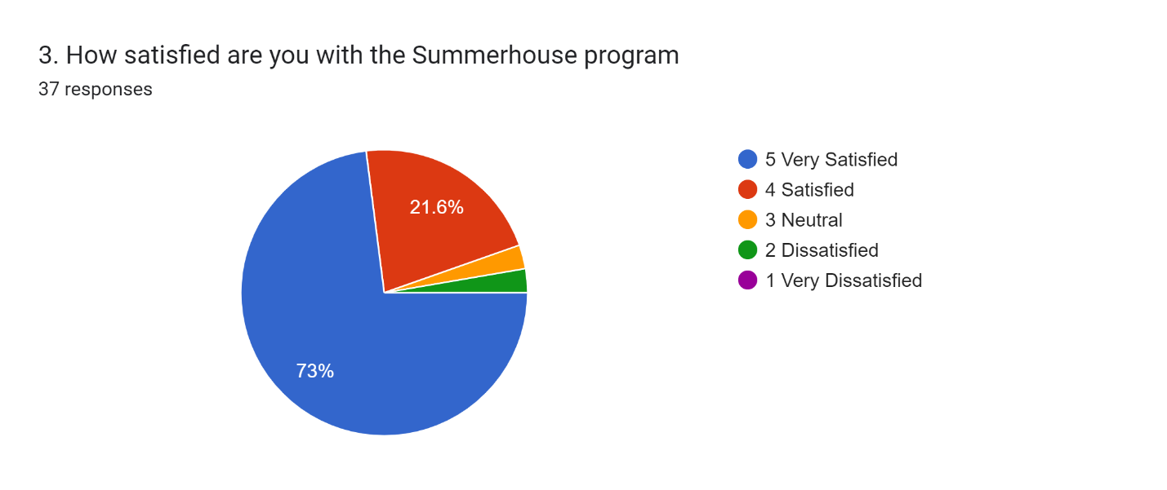

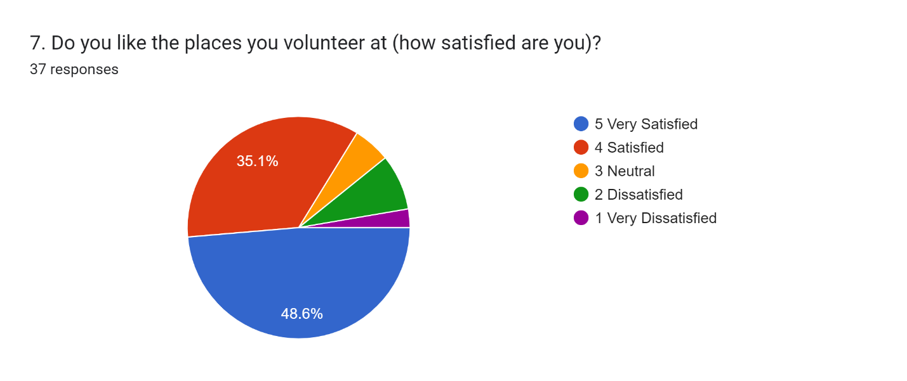
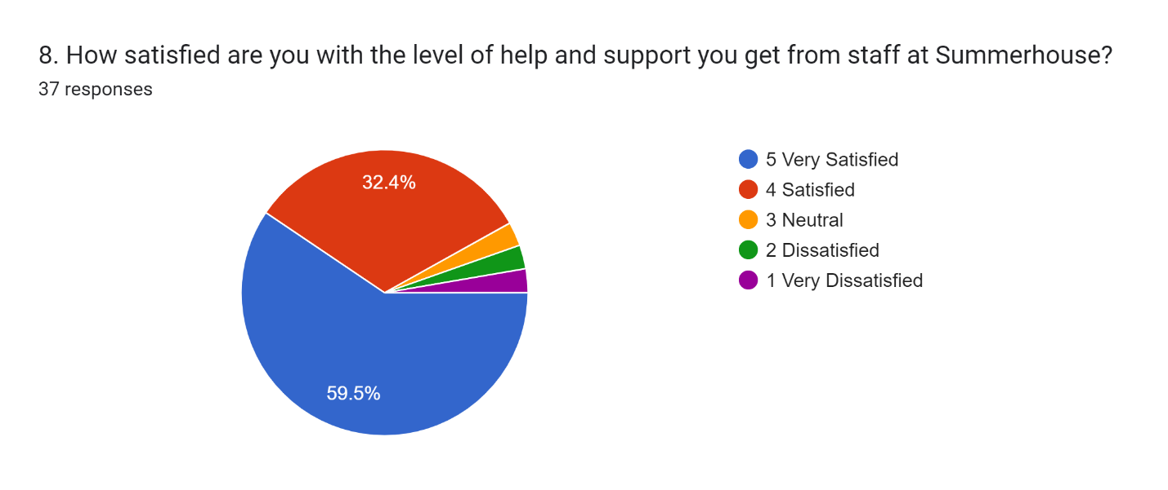

Family member surveys went out in the Summer of 2023, receiving 20 responses. Service satisfaction rates reached 100%, successfully meeting and exceeding the established goal.
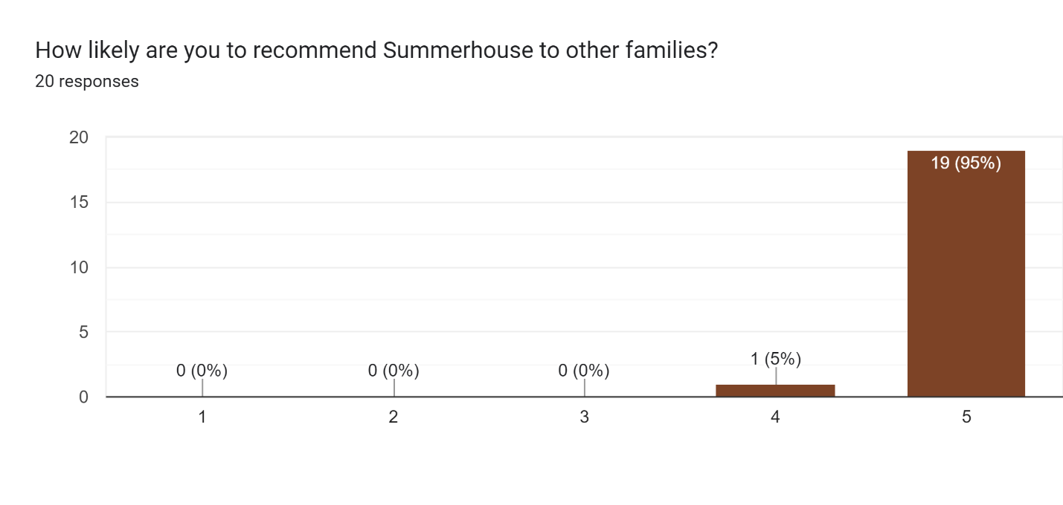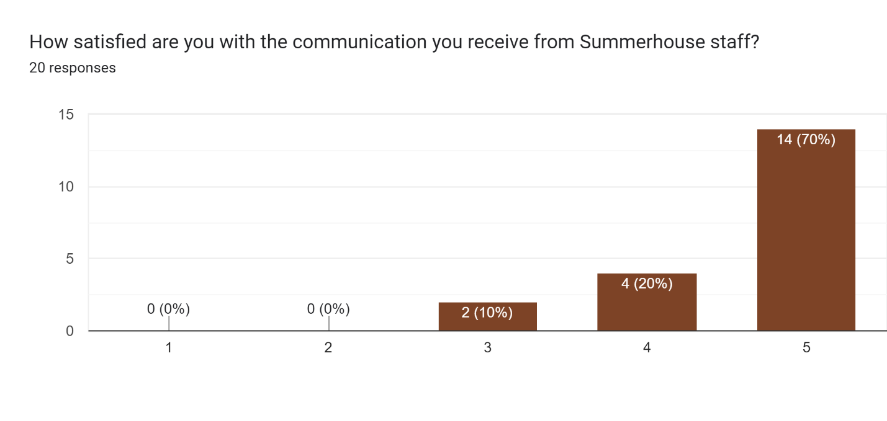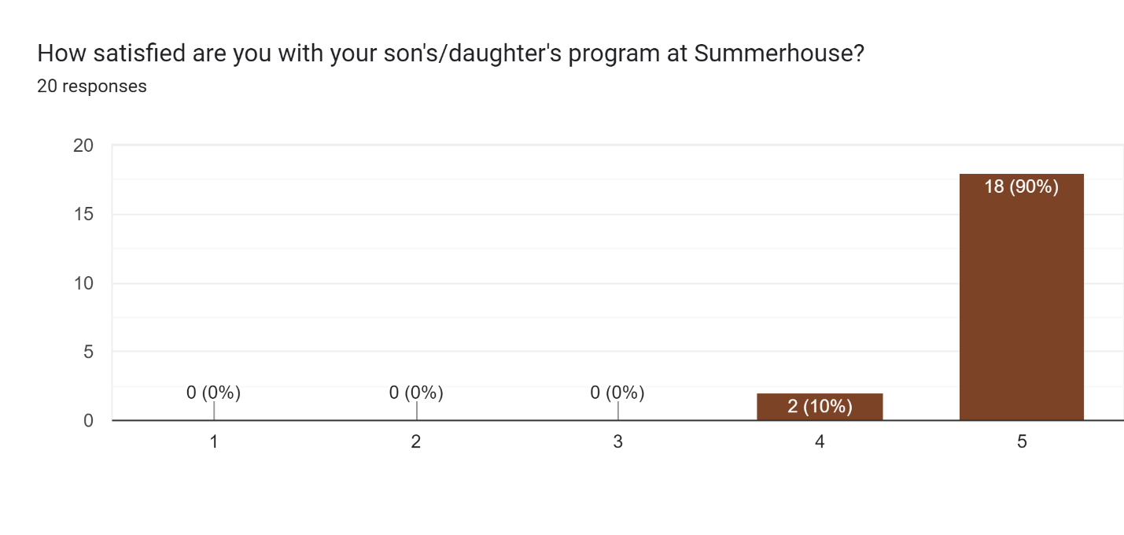

What do you think your son/daughter’s favorite things to do at Summerhouse are:
Working and Shredding
Working and volunteering in the community being part of the community and going to different places in our community. This is such a great learning experience for all involved.
Going out on the job sites/volunteer sites; field trips; visit with friends, interaction with staff; Endless Fitness
Fun Friday. Spending time with friends
The daily activities and seeing her friends.
Food Bank, Shredding, going out to lunch, MAM, Fun Friday
Fun Fridays; Houston Food Bank; Harris County Pets
Shred Pickup
Food Bank and grocery shopping.
Volunteer work, playing games, planning schedules, eating out with friends
TRIPS/ADVENTURES OUT INTO THE CITY
Volunteer work
Fun Fridays, endless fitness and going to the park to play different sports
Go out in community! He loves bowling, dinosaurs alive, swimming.
Going out to eat and on fun Friday events
volunteering at service organizations
shred for independence, meals on wheels, going in the community for activities, going to lunch
Kid's meals, social club, bowling and shredding
Volunteering at the Food Bank, socializing and just being on the go.
Volunteer at nature center and going to park/beach/basketball

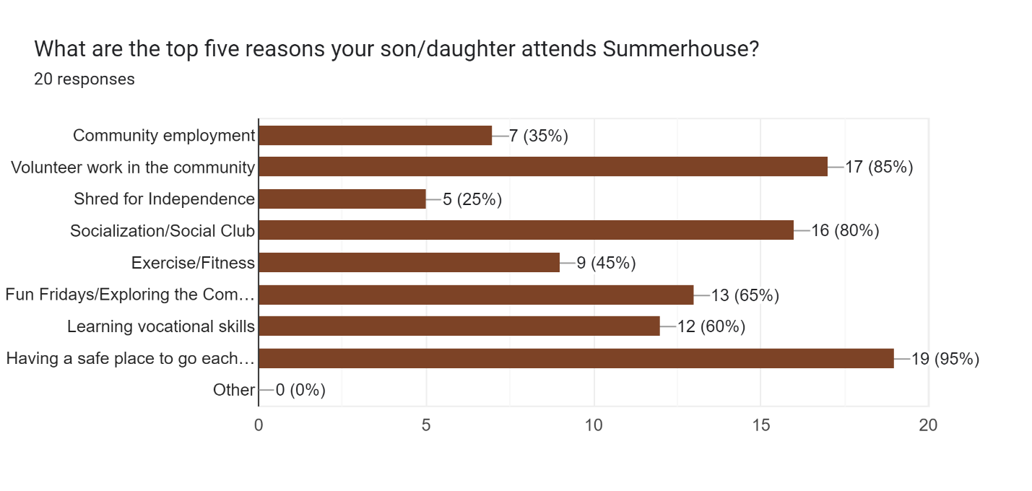
What do you appreciate the most about Summerhouse?

That our son is with people who truly care about his developmental progress
The people who work there and work with our kids
Our son feels appreciated, supported and part of a group, his being able to work in the community, opportunity for him to find a job again
How much she enjoys attending.
It is a safe place for my daughter to go
Small groups, amazing staff, being very busy with a variety of daily activities, positive environment
Safe place to go each day
Positive engagement
The help and support from staff.
safe and fun, individualized plans, community, outreach and employment opportunities
STAFF TO MEMBER RATIO
Socialization
She loves coming every day
How you all seem to genuinely care about Paul.
Caring, accepting and kind staff
Dedicated staff and a well developed plan for my child
The dedicated and specialized staff that love and care for my daughter
Summerhouse is the place my daughter enjoys the most. If she is happy then I am happy. It is a safe place. I know my daughter is surrounded by people who love and support her.
Keeping him active and getting him out in the community. Looking forward to employment.
Teachers are very caring and are a pleasure to be with

What would you like to see changed at Summerhouse?

More time daily
Making a larger space for everyone. Which is happening now yay!
Being out in the community more than has been able to be done this summer (but understand), communication on a more regular basis (with the staff turnover it seems like not as good as had been in the past)
Just to remember that not all of the families are wealthy so when we are asked to donate for the building campaign it’s not because we don’t care but we financially aren’t able too. We want what’s best for our kid so we budget so they can attend SH as we believe it is the best place for them to be.
Less surveys and paperwork. Redoing what we did last year is annoying. The billing invoice is sent and due the same day and we get notices every day until the payment arrives at Summerhouse.
A residential program would be amazing or even a part-time option to stay a weekend or week if parents are out of town
Very little needs changing. Onsite lunchtime nutrition could be reviewed, though we realize there are limitations.
Better communication, especially about more sensitive subjects than daily activities
ideally - group living w on-site employment and/or transportation options
CLOSER TO THE NORTHEAST SIDE
Daily feedback on member’s day
Trying to find some healthy restaurants and helping her make good choices when eating out
not sure
Nothing
nothing that I can think of
Closer to us/transportation

Satisfaction surveys were also sent to our regular volunteer sites. The results are as follows:
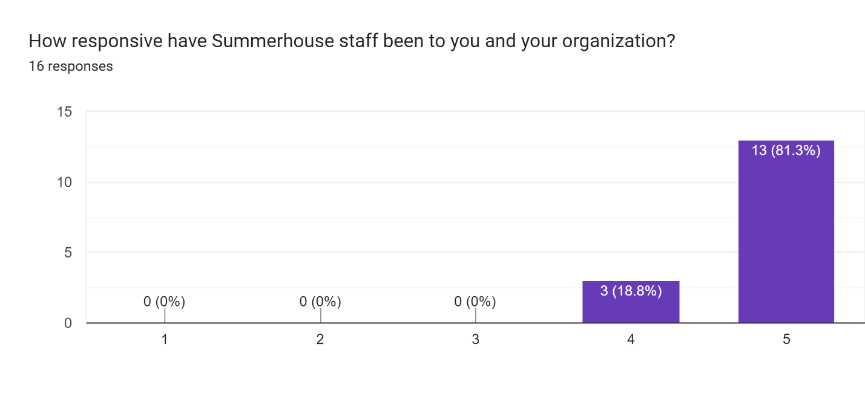
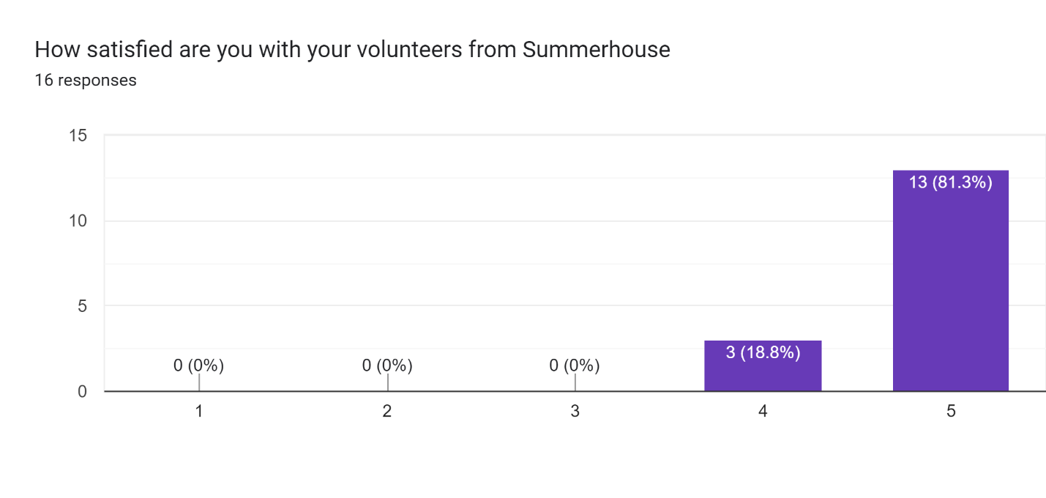
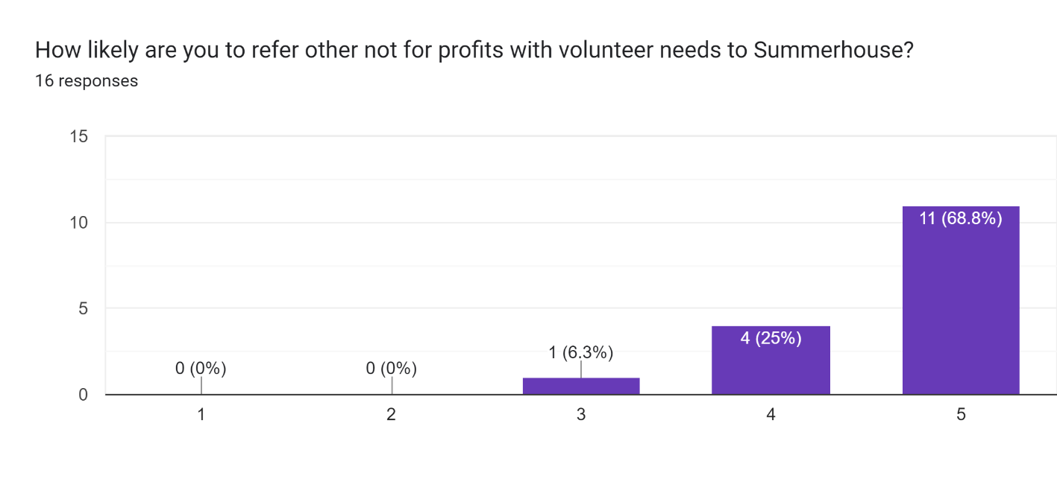
What do you appreciate most about Summerhouse? What do you think they do well?

Always willing to do whatever was needed
they all understand our mission
I appreciate their willingness to help with any activity, their positive attitudes, self awareness. They excel in repetitive tasks (which we have tons of)!
Summerhouse is eager to help and that is very significant in volunteering.
Kind, caring staff. Great, enthusiastic kids.
Summerhouse staff are excellent advocates for the volunteers. They provide support and encouragement to the volunteers and make every effort to help the volunteers be successful.
Dedication in service and great communication.
I love how the volunteers are committed to working at MAM and have a lot of pride in their work. The more experienced volunteers love to show the new ones how to do things. The Summerhouse staff are always amazing and wanting to help at MAM.
The leads are always positive and helpful - both with the volunteers & with our staff. They work well with the groups, being patient when teaching & helping during shifts. Truly, the leads make the difference.
I appreciate the good attitudes that everyone comes with. They are a great group and are happy to help with any task that we ask of them.
Dedication and consistency.
Consistency, willingness to do what is asked, friendly
Summerhouse volunteers are always cheerful, helpful, and enthusiastic. They are great at teamwork and are up for any challenge :)
They are very responsive to anything asked of them to do and the clients are fun to work with at LOTS.
Dedication to volunteering. Working together and completing the task!

What would you like to see improvement on?

Consistency with arrival times
We love all of the groups that come to L&F from Summerhouse.
Nothing, it's a great partnership for us. Keep up the amazing job!
Keep a standard schedule and notify us if not coming. If Summerhouse books on the 4th Wed of the week, HPC puts this on our calendar for future dates and does not take off unless Summerhouse Cancels a date. Canceling often or anytime is fine and we understand.
Signing up for shifts prior to arrival.
Summerhouse volunteers sometimes visit the warehouse without a registration and waiver. BBK requires volunteers to register and acknowledge our liability waiver. Each volunteer, including any staff, needs to complete a registration online or a paper waiver for every volunteer shift and/or visit to the warehouse.
Learning more about your program.
Cannot think of anything.
Can't think of anything.
N/A - We are so grateful for Summerhouse!
If they could let us know at least a day in advance, when they will be serving at LOTS would be very helpful.
Mindfulness when following the schedule, particularly when asking for the monthly schedule in advance. More so for Bekah's schedule.

We also sent a survey to Collaborating Medicaid Providers, but we received no responses.

Community Employment Services

In 2023, our Community Employment Program experienced significant growth and enhancements. A full-time director was added, and the program has expanded to a dedicated team of 5. The SES staff have actively worked to become fully credentialed by UNT, which is a requirement for TWC funding) to cover programs such as Job Skills Training, Job Placement, Supported Employment, and Autism Endorsement.

Our employment program’s placements encompassed a diverse range of members and clients getting jobs, work experience sites, Summer Earn and Learns, and placements for TWC clients. Since the inception of the program, we have successfully served over 100 individuals. Ongoing efforts involved building and strengthening relationships with employers and TWC counselors. The expanse of physical space in the building addition has greatly accommodated the needs of the employment staff.

Other highlights include:

- To increase our service offerings to the Houston community we expanded services in several ways. We added territory outside Harris County to include Fort Bend County which contains parts of Katy, Richmond, Rosenburg, Sienna, and Sugarland. We attended the Fort Bend Transition and Resource Fair for the first time. To build relationships and gain new clients, we spoke at Seven Lakes High School in Katy.
- We expanded our services to include work-based learning internships and supported 7 interns. Several were returning clients from our Pre-ETS classes.
- On our journey to make employment accessible for all, we forged new partnerships with employers like Walmart, HEB, Dig World, Rainforest Café, CyFair ISD, TEAM Approach and TJMaxx.
- In cooperation with the Day Program’s commitment to empowering members in their pursuit of meaningful employment opportunities we participated in PATH meetings and secured new employment opportunities for 3 members. We are actively working with 3 members seeking new employment while supporting another 5 members through the TWC process to open a case.
- In support of National Disability Employment Awareness Month (NDEAM) held our first Career Connections event celebrating and supporting integrated community employment. We hosted an employer roundtable sharing their experience and best practices, invited a peer speaker to share his employment journey, and brought in employers to meet members.
- To empower the professional growth and development of our staff and program we invested in sending 2 department leaders to the National APSE Convention over the summer.

As of 12-31-23, we served 42 clients, with 11 of them being members.

- Characteristics of clients in employment program in 2023.

Males: 34
Females: 8

Average age: 26.3

Autism 31
Mental Health 1
IDD 10

Caucasian: 28
African American: 9
Asian 2
Mixed 3

Hispanic 9
Not Hispanic 34

Discharges

A - Work experience only.
A - Quit position, now in a day program.
A - Successful closure/working.
C - Successful closure/working.
C - Quit position/reapplying to TWC.
D - Work experience & SEAL only.
M - SEAL only
R - Work experience only
R - SEAL only
A – Referred to another provider/conflict of interest
J – Requested a new provider

- Effectiveness

Maximize percentage of referrals obtaining employment: In the past year, we achieved 16 placements, falling short of our goal of 25 but surpassing the 2022 actual of 11. Contributing factors included a staff member facing significant health challenges and subsequently resigning, the time required for staff credentialing through UNT (a TWC requirement), and the intricate paperwork demands of TWC. To address these challenges, we took proactive steps by appointing an Employment Director in January 2023 to provide comprehensive oversight and support for the department. Additionally, we increased the staffing level to four members under the director. Recommend keeping this goal and increasing it to 30.

Maximize percentage of placements retained at 90 days (retention): This goal assesses the retention of new placements over the previous quarters, focusing on individuals who remain employed for at least 90 days. At the 90-day mark, 92% of placements were still actively working. This surpasses our goal of 90% and represents an improvement from the 2022 rate of 83%. Recommend keeping this goal.

- Efficiency

Decrease the time from SA to CPA completion. This was a new goal for this year. The goal was 90 days, and the actual was 60 days, which meets and exceeds the goal. Recommend keeping this goal.

- Service Access

Maximize the percentage of referrals taken (acceptance rate): We took in 37 referrals this year, slightly below the 45 referrals in 2022 and our goal of 50. The decline is primarily due to fewer Pre-ETS classes. To address this, we’re increasing staffing capacity, strategically marketing our services to schools and TWC offices, and increasing the available Pre-ETS classes now that there is a dedicated classroom. Recommend keeping this goal as well as adding a goal to work with 500 persons by 2027 to match the strategic plan.

- Satisfaction
Client and family surveys were sent out in the Fall of 2023, receiving 7 responses. The satisfaction rates with services reached 86% rated 4 or 5, under our goal of 100%. Results are as follows:
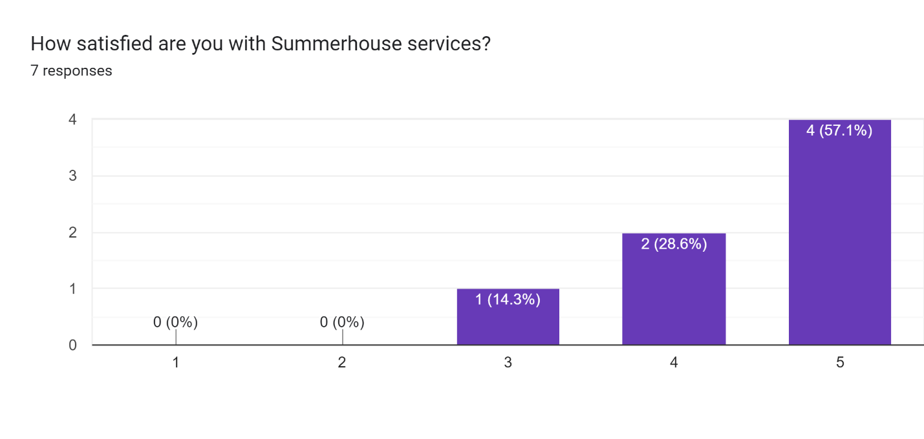
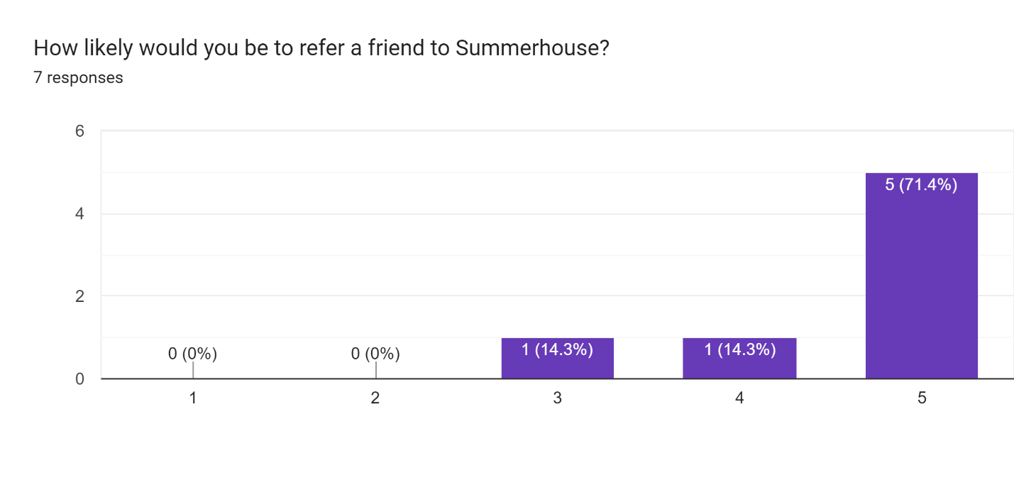

Any comments about what we do well?

Every time I visit the office I love how welcoming everyone is staff and the clients you serve.
I like that me and Melissa work very well with me together
The coaching, not just on task or skill related aspects of work, but also on social and perspective-taking aspects of work (and work-related activities such as job search, interviewing, responding, sharing, etc.) has been instrumental in my son's overall development and in growing his skills.
Summerhouse manages a comprehensive and individual plan for each individual so well. Very engaging team, considering possibilities outside the 'traditional' box.

Any comments about how we could improve?

We could improve by getting a tour of the job sites before interviews so they can see what it looks like beforehand and know they like it
Open a residential division . . . we'd be first in line.

We sent satisfaction surveys to all employers. We only had 2 responses. Both (100%) were satisfied or very satisfied with our services. Recommend trying other ways to get more feedback next year (perhaps bringing by a written survey.)

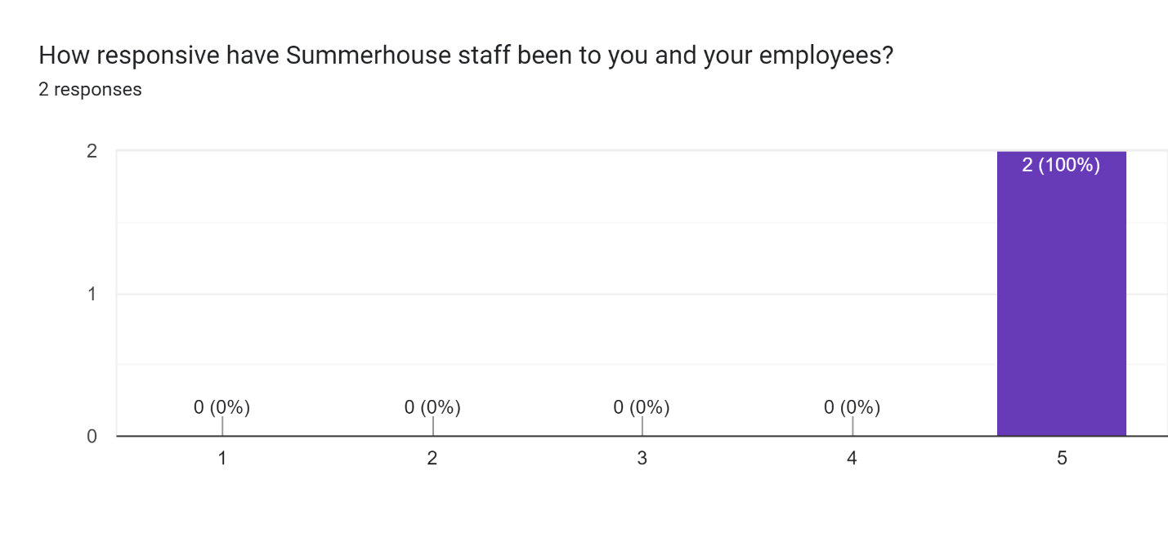
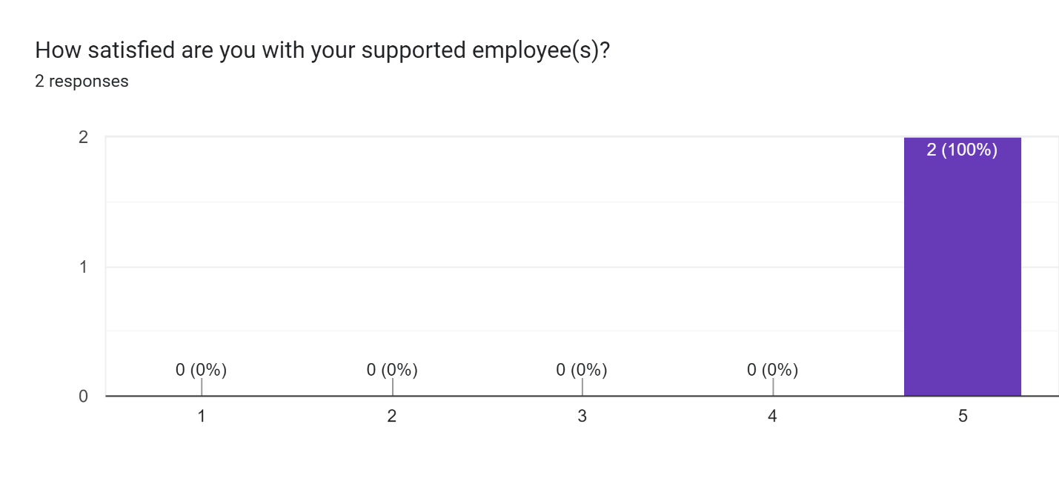

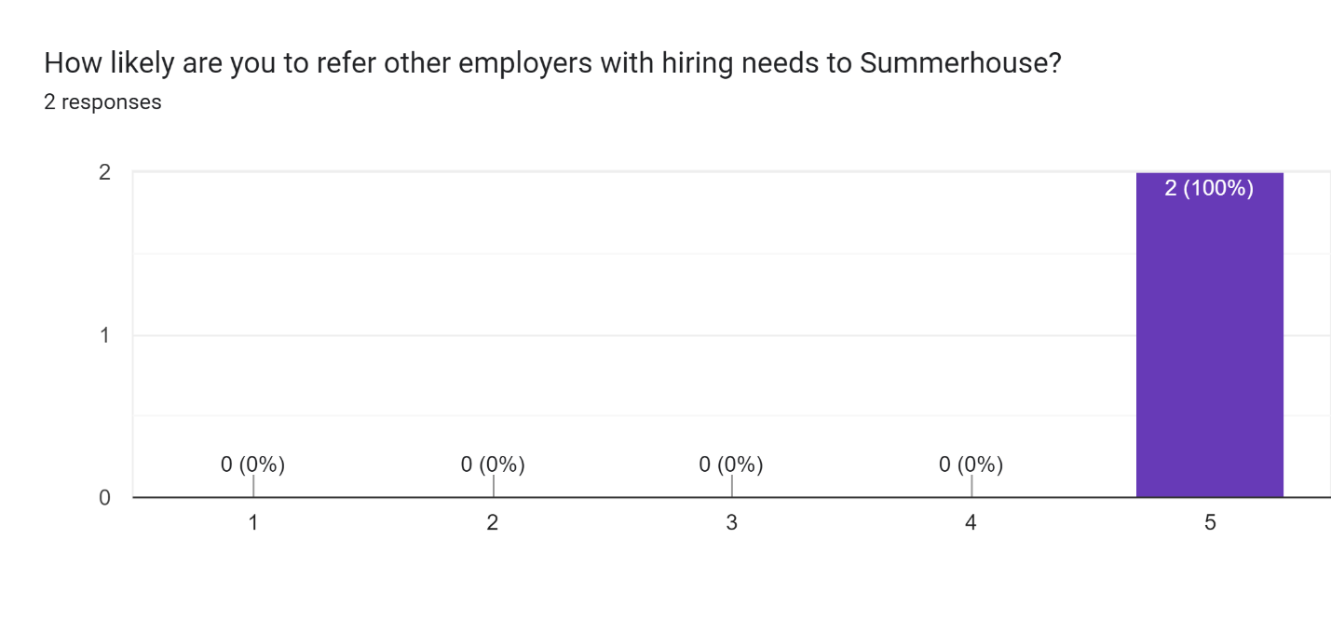
What do you appreciate most about Summerhouse? What do you think they do well?

Consistency. Repetitive tasks.
Communication is great

We also sent satisfaction surveys to our TWC partners. We only received one response and it was very positive.
Business Functions

Additionally, see our Strategic Plan and its progress, Risk Management Plan and progress, Accessibility Plan and progress, Technology Plan and progress, critical incident analysis, and complaint analysis.

The following business functions were tracked in 2023:

- Increase # of members attending SHH program.
Membership increased from 39 to 40 members in 2023, with a couple more scheduled to start in January/February 2023. Our maximum capacity is 40 (FTE).

- Increase revenue to cover all costs of employment services.
The aim was to achieve cash positivity by June 2023, but the goal was not met (we had a deficit of $6,000). However, we came close, thanks to several grants designated specifically for employment.

- Increase $ from foundations and corporations and individual donations.
We secured $523,500 from foundations and corporate sponsors this year, surpassing our goal of $100,000. Our collaboration with Blaise Fallon (consultant) on a stewardship program is ongoing.

- Increase $ from annual fundraiser(s).
Our annual golf tournament yielded $71,776, and our annual Gala generated $67,870. Additionally, we were the beneficiary of another golf tournament, raising $ 70,000.

- Reduce staff turnover.
In 2023, we experienced a turnover of 6 staff: one pursued further education, two left for health reasons, one secured another job, one relocated, and one was terminated. Despite these changes, our retention rate stands at 93%, surpassing our goal of 85%.

- LEIE checks completed on time.
All completed on time meeting said goal.

- Increase the number of volunteers.
We enlisted the support of over 55 volunteers, mainly contributing to fundraisers. However, securing volunteers for program assistance remains challenging.

- Reduce critical incidents.
We recorded 85 incidents (our quarterly goal is less than 25), marking a decrease from the 153 incident reports the year prior. Please refer to the critical incident analysis for further details.

- Reduce grievances.
We had three complaints this year. See complaint analysis.

- All health and safety training for members and staff completed.
All completed on time/goal met.

- Inspections completed and all recommendations addressed.
All completed on time/goal met

- All drills completed at least annually.
All completed on time/goal met

Other items tracked included:

# on Scholarships = 8 currently on scholarships.

Progress on building addition = Construction completed.

In September 2023, we administered an employee satisfaction survey, receiving 15 responses. The results are outlined below:

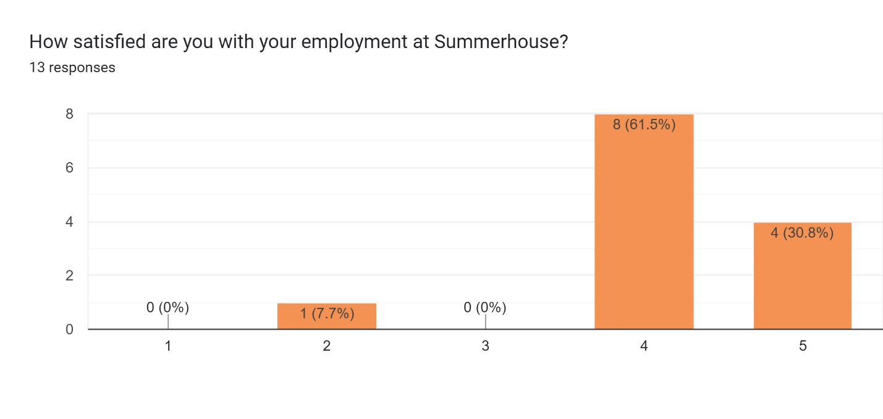
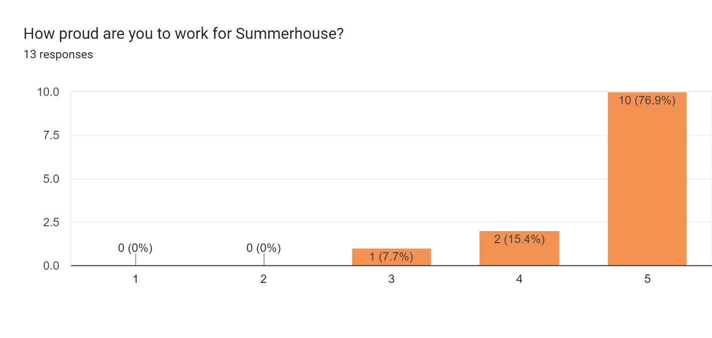
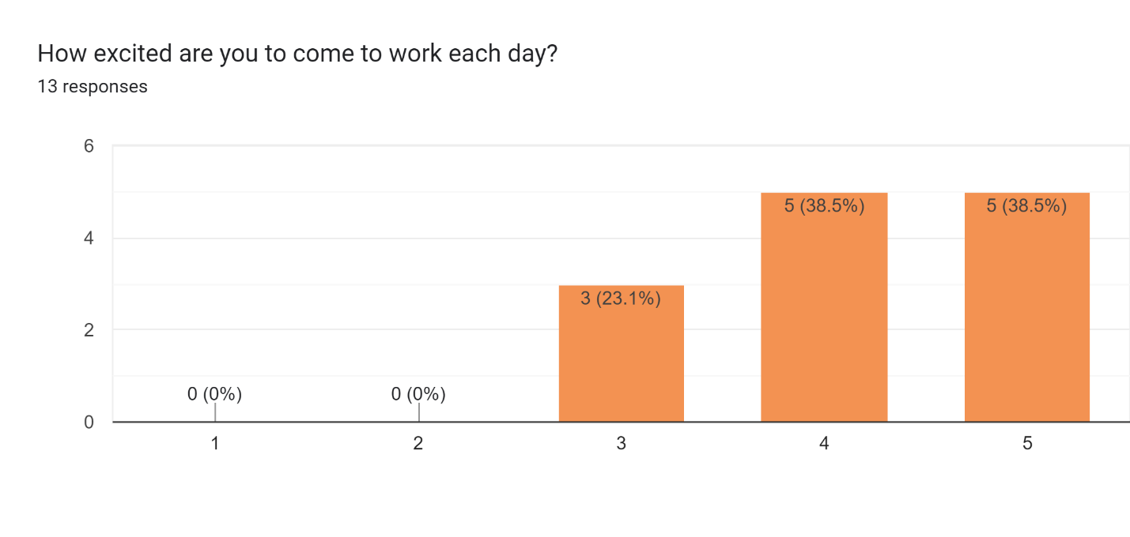
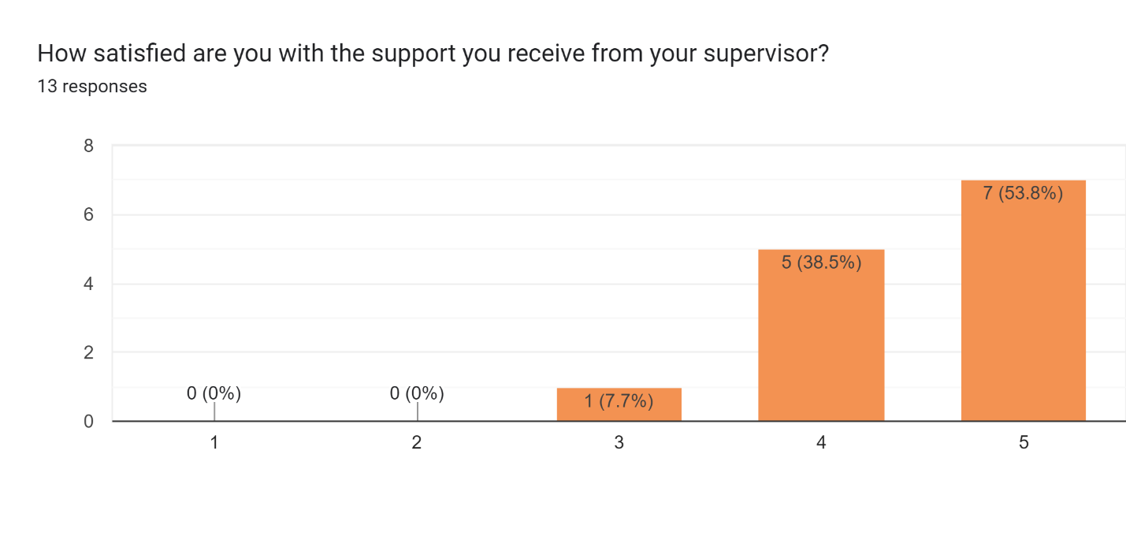
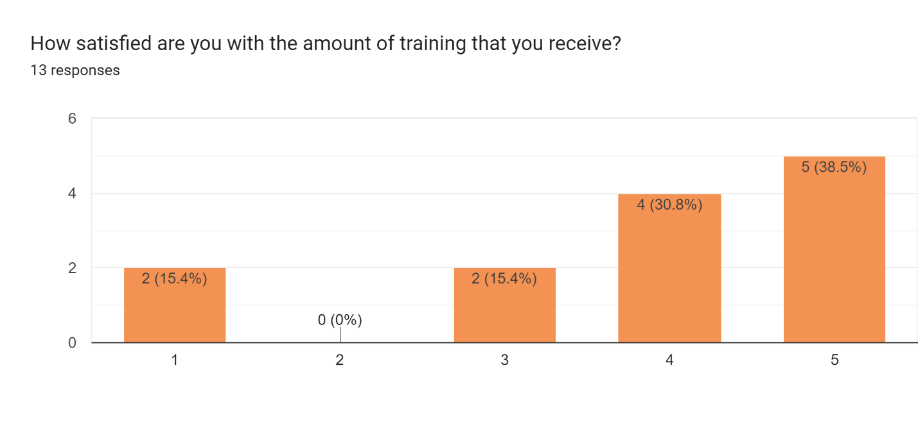
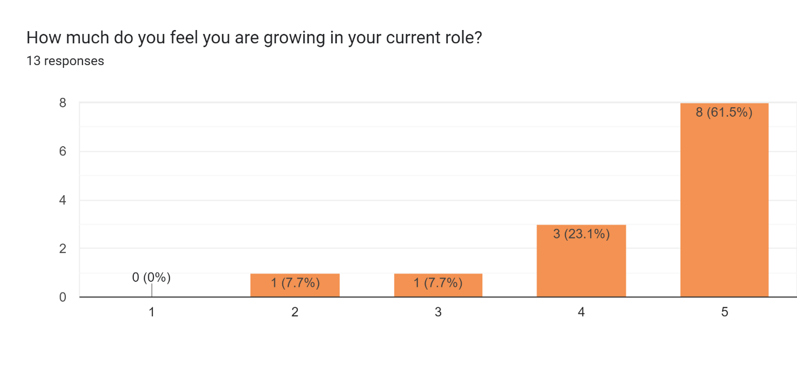
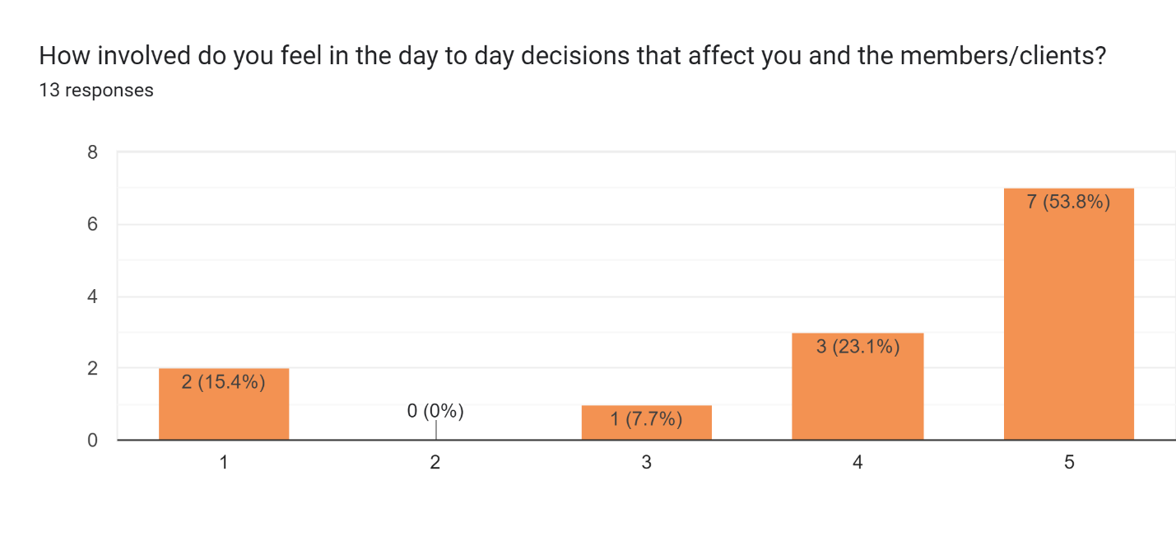
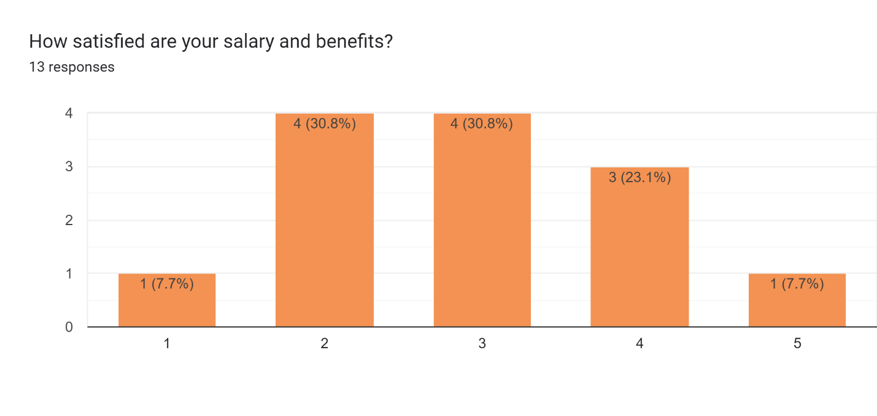
Name 3 things you love/appreciate about your job

Work life Balance, making a difference in their lives and seeing them happy when they have gained employment, friendly and supportive staff
members, co-workers, the impact SH makes in the community
Leaving and knowing that I made a difference each day, whether I see it or not. The ability to see growth, both with the members/clients and with Summerhouse itself My co-workers!! They have the biggest hearts and willingness to support others no matter what. The fact that we can rely on each other and build each other up is priceless.
The staff that we work with! The amazing members that we get to work with! The core values of Summerhouse! <3
Management, support, members
Co-workers, member interactions, feeling valued
We treat adults like adults, I feel valued and supported, it’s a very positive environment.
The overall support from everyone, and the positive environment.
Co workers!
Team building activities! Flexibility with management! our members, coworkers, and families.
I truly appreciate everything about this job I don't think I could pick just 3 things but I will say this is my favorite staff that I have ever worked with.
i love helping others, i like the friends i have made working here, i love that we get to volunteer so much
That it’s not an office job, that it’s person centered most of the time, paid lunches

